Belize Mission Trip 2020
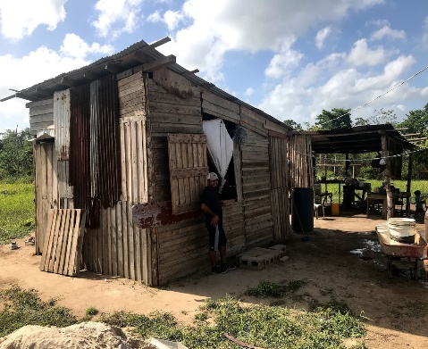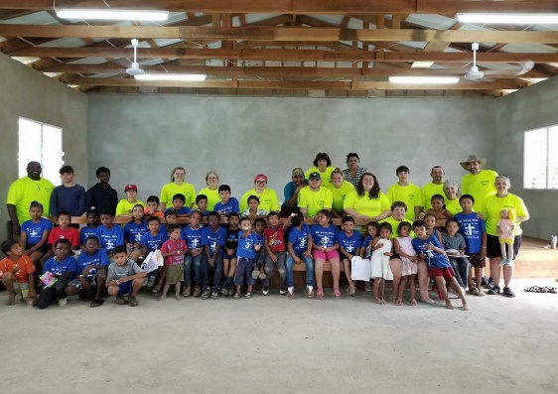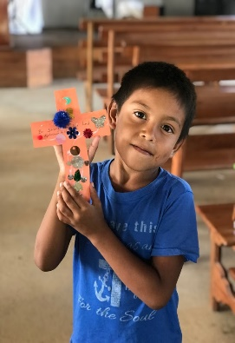
But you shall receive power when the Holy Spirit has come upon you; and you shall be witnesses to Me in Jerusalem, and in all Judea and Samaria, and to the end of the earth. Acts 1:8
ARE YOU LOOKING FOR AN INTERNATIONAL MISSION TRIP FOR YOU OR A GROUP? If you have never been on a Mission Trip or you are a seasoned missionary, this is the International Mission Trip for you! Because of the overwhelming interest in these trips we have two trips this year. Which one are you interested in going on: June 22-30 and July 20-28? I have been traveling to and leading groups to Belize for 22+ years where we have built a network of contacts and resources, so everything will be taken care of for you on this trip. You or anyone that you know are welcome to join this great opportunity for an 9-day mission trip to Belize.
This will be one of the most rewarding experiences your will ever be a part of. You will be serving others alongside of fellow Believers with a Christ-centered mindset. The Mission Team will travel to Central America to the beautiful country of Belize where we will minister to the people in the impoverished villages outside the capital city of Belmopan. The team will be staying in Belmopan with a native Pastor and Missionary from Belize, Job Lopez. Each day there will be a time of group/personal evangelism in many different areas in the city and/or in different villages. We will also be holding VBS on July trip as well as constructing and repairing on churches/houses on the June trip. The cost of the trip will be $1350 per person (plus $120 per person ministry fund). There is an initial nonrefundable deposit of $100 that needs to be paid as soon as possible to secure your place on the trip and know that there is a limit of 17 people on each trip (your spot will not be secured until this deposit is paid). An additional $600 payment is due 12 weeks before the trip and the final payment (remaining balance and the $120 ministry funds) is due two weeks before departure (These amounts, and times are non-negotiable and refundable unless otherwise stated). some exceptions and restrictions apply, please let me know if you have any questions or concerns.
What will you need to provide for this trip? Because this trip is international, you will have to provide a current U.S. Passport (with more than 6-months left before expiration, from trip day) and you would want to check with your local doctor and get his/her advise on any vaccinations, shots, or medicines they would recommend. Because the cost of this trip is kept as low as possible, the team will need to raise an additional $2000 for each trip (to purchase Rice, Beans, and other building supplies/necessitates that will be needed for ministry on the trip (also called “Mission Funds” above) to distribute and/or use while in Belize. This averages to $120 person. Each person will be expected to raise this. If not, the $120 per person will be added to the individual cost (called “Mission Fund above). If you, someone you know, or a business would like to support the trip by donating, please let me know, any donation is tax deductible and would be appreciated. All other costs (airfare, meals, travel, transportation, fees, luggage fees (limited to one checked bag), housing, excursion, day trips, etc.) for the trip will be included in the per person price of $1350.
What will the accommodations be while in Belize? We will stay in a Mission/Ministry house in Belmopan, dorm style with bunk beds. Meals will be: Breakfast (mostly native items), lunch (peanut butter crackers, protein bars, occasionally full meals, etc.) and dinner (either freshly made or at a local restaurant). The lunch meal is as such so we will not have to travel back to town each day but can stay in the villages doing ministry. All meals are included. The last full day of the trip will be an excursion day. There are several possibilities that will be discussed and determined closer to the time of the trip. The price of the excursion day is also included in the cost. During the week, we will be distributing beans and rice while also doing door-to-door evangelism in the villages. As previously mentioned, we will hold our 4rd annual Belize VBS on the July trip. While, the June trip will focus more on construction (either on houses or on a local church). Because this is an international mission trip, any and all of these plans are subject to change based on the doors the Lord opens or closes! Also know, you will be in a foreign country and things may have to change based on varying circumstances (weather, natural disasters, church needs, ministry possibilities, etc.).
Is there training required for the trip? Yes, there will be (3) Training Sessions leading up to the mission trip and everyone is required to attend each these sessions. Anyone who does not attend the trainings will have to make arraignments to watch the videos of the training. I will have a training video out that will go through the process for those that are attending from churches out of the local area. This training will help each person to train on witnessing to others as well as help you prepare mentally and spiritually for the trip. There will also be a Daily Bible Study that I will write and distribute to prepare us as a team for the trip.
For those that need help financially from the Timpson/Nacogdoches areas, there will be several fundraisers scheduled. The monies raised for each fundraiser will be divided among those that help with the fundraiser based on the proportion of time worked and profits made. Also, any personal fundraisers that you would like to do for your personal trip costs, must be discussed and approved by Bro. Dee prior to it being scheduled or any promotion is done for it. This is to avoid any conflict with group fundraisers. Any monies (other than deposit monies) raised during these fundraisers, if they are not used, will go into a Mission’s Account to fund future mission trips, they can be diverted to another person’s trip, or they can be saved for you for one year. If you have any questions, please contact me at the numbers or emails listed below about a trip or fundraisers. God is doing a mighty work through our mission teams in Belize and I would love to have you get in on what He is doing! God bless, and I look forward to you coming along with us on this great opportunity to share the Word of God and minister to the poor and needy, as we go to “the ends of the earth” with the love of Christ.
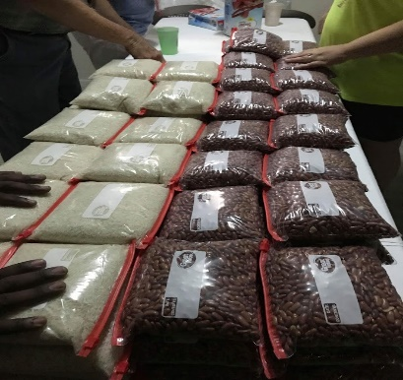
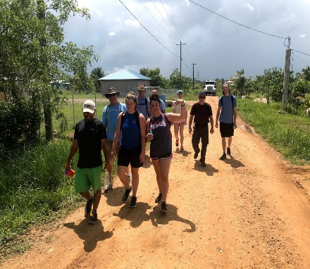
In Christ’s Love,
Bro. W. Dee Daniel, Pastor
First Baptist Church
Church- 936.254.2220
Cell- 936.332.0387
Personal Email- wdeedaniel@yahoo.com
Church Email- firtsbctimpson@yahoo.com

All authority has been given to Me in heaven and on earth. Go therefore and make disciples of all the nations, baptizing them in the name of the Father and of the Son and of the Holy Spirit, teaching them to observe all things that I have commanded you; and lo, I am with you always, even to the end of the age. Amen. Matthew 28:18-20

